|  |  |  |
| --- | --- | --- |
| **Purpose/Type of Test** | **Input** | **Expected Result** |
| Testing Multiplication button  and also numbers 7, 8 and 9 | Input calculation 78 * 9 = | **Expected Result.**  This means button 7, 8, 9 and the multiplication button all work as expected and also, the calculation gives correct result. |
| Testing Division button and also numbers 4, 5 and 6 | 45 / 6 = | **Expected Result.**  This means button 4, 5, 6 and the division button all work as expected and also, the calculation gives correct result. |
| Testing Addition button and also numbers 1, 2 and 3 | 12 + 3 = | **Expected Result.**  This means button 1, 2, 3 and the addition button all work as expected and also, the calculation gives correct result. |
| Testing Subtraction button and also numbers 3, 6 and 9 | 36 – 9 = | **Expected Result.**  This means button 3, 6, 9 and the subtraction button all work as expected and also, the calculation gives correct result. |
| Testing “equal to” button | 1 + 2 = | **Expected Result.**  This shows the “equal to” button works as expected and also, the calculation gives correct result. |
| Testing “0” button and also number 0 | 0 | **Expected Result.**  This shows the “0” button works as expected. |
| Testing text field box | 0123456789 | **Expected Result.**  As shown in the print screen, all the numbers are on the button are displayed in the text field. |
| Testing Clear button | Clear | **Expected Result.**  This shows the “0” button works as expected. |

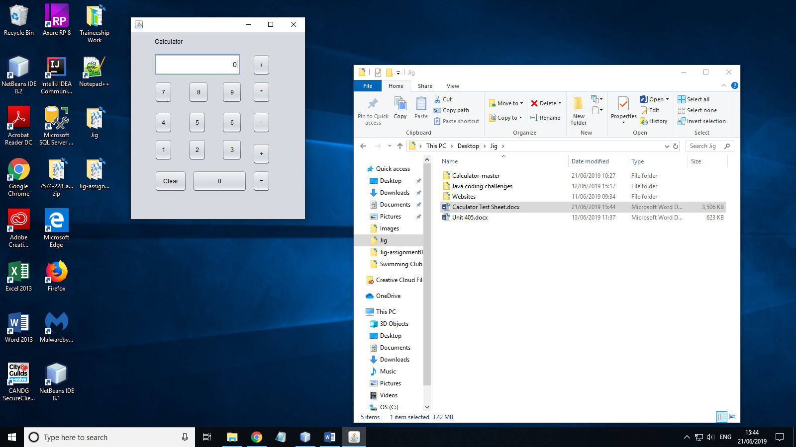

**Task C**

1. Delay functions can be used while coding an infinite loop, to prevent the code from crashing.

2. if RefNo>=50 and RefNo <= 1000 output “valid reference number”